**CanisHerz – Sistema embarcado para medição cardíaca em tempo real de cachorros domésticos**

*CanisHerz - Embedded System for Real-Time Heart Measurement in Domestic Dogs*

*CanisHerz - Sistema integrado para la medición cardiaca en tiempo real de perros domésticos*

**Miguel Gustavo de Sousa Campos**

*miguel.campos3@etec.sp.gov.br*

**Pablo de Sousa Santos**

*pablo.santos125@etec.sp.gov.br*

**Ricardo Luquetti Codo**

*ricardo.codo@etec.sp.gov.br*

**Victor Hugo Navarro Taveira**

*victor.taveira@etec.sp.gov.br*

|  |  |
| --- | --- |
| **Palavras-chave:**  *Cardiopatias.*  *Equipamento vestível.*  *Aplicativo.*  *Cães.*  **Keywords:**  Heart disease*.*  Wearable device*.*  *Application.*  *Dogs.*  **Palabras clave:**  Cardiopatías*.*  Dispositivo vestible*.*  Aplicación*.*  Perros*.*  **Apresentado em:**  05 dezembro, 2024  **Evento:**  7º EnGeTec  **Local do evento:**  Fatec Zona Leste  **Avaliadores:**  Avaliador 1  Avaliador 2  [Desenho com traços pretos em fundo branco e letras pretas em fundo branco  Descrição gerada automaticamente com confiança média](https://creativecommons.org/licenses/by-nc-sa/4.0/) | **Resumo:**  A presença de cardiopatias em animais domésticos revela um problema recorrente, porém, de pouco conhecimento social. No Brasil, a grande maioria desses pets são cachorros, ressaltando a necessidade de uma solução eficiente. Este projeto propõe a composição de um equipamento vestível que monitora, em tempo real, a frequência cardíaca dos cães. Composto por um dispositivo e uma aplicação, o aparelho coletará os batimentos e alertará caso identifique irregularidades. Para o entendimento e aprofundamento do tema pautado, a metodologia qualiquantitativa mostra-se de grande relevância para a efetivação da pesquisa, entregando um volume satisfatório de dados comprovatórios, necessários para o molde e conclusão do projeto. A problemática evidenciada mostra-se um desafio para o animal e seus cuidadores. Seus sintomas, mesmo incomuns, são de difícil detecção, considerando a barreira comunicativa existente. Como resultado, almejamos a diminuição desses casos, auxiliando no atendimento, tornando-os mais ágeis. Em conclusão, espera-se que essa solução inovadora auxilie significativamente para a prevenção de emergências e a melhoria geral do bem-estar dos cães.  **Abstract:**  The presence of heart disease in domestic animals reveals a recurrent and little known problem in society. In Brazil, the vast majority of these animals are dogs and these cases highlight the need for an effective solution. This project proposes a wearable device that monitors the heart rate of dogs in real time. The device, consisting of a device and an application, will collect the heartbeat and alert in case of irregularities. To understand the problem, the case study methodology is relevant to the research, as it provides a satisfactory volume of data, necessary for the completion of the project. This problem is proving to be a challenge for the animal and its caretakers. Its symptoms, although infrequent, are difficult to detect given the existing communication barrier. Therefore, we aim to reduce the number of such cases, helping with service, making them more agile. In conclusion, this innovative solution is expected to significantly help prevent emergencies and improve the overall well-being of dogs.  **Resumen:**  La presencia de cardiopatías en animales domésticos revela un problema recurrente y poco conocido en la sociedad. En Brasil, la gran mayoría de estos animales son perros y estos casos ponen de manifiesto la necesidad de una solución eficaz. Este proyecto propone un dispositivo vestible que monitoriza el ritmo cardíaco de los perros en tiempo real. El aparato, compuesto por un dispositivo y una aplicación, recogerá los latidos del corazón y alertará en caso de irregularidades. Para comprender el problema, la metodología del estudio de casos es pertinente para la investigación, ya que proporciona un volumen satisfactorio de datos, necesarios para la conclusión del proyecto. Este problema está resultando todo un reto para el animal y sus cuidadores. Sus síntomas, aunque infrecuentes, son difíciles de detectar dada la barrera de comunicación existente. Por ello, pretendemos reducir el número de casos de este tipo, ayudar en el servicio, haciéndolos más ágiles. En conclusión, se espera que esta solución innovadora ayude significativamente a prevenir emergencias y a mejorar el bienestar general de los perros. |

1. **Introduction**

Heart disease, according to Feldman (2024), is a general term that covers any disease of the heart. This can include a variety of conditions, such as cardiac arrhythmias. Its presence in domestic animals reveals a recurring problem, but one that is little known in society. According to the Animal Rights News Agency (2013), Brazil has approximately 57 million pets, and 7% of their deaths are caused by heart disease. Of this percentage, 37 million are dogs, which account for the majority of cases. The causes of the development of these diseases are varied, as pointed out by the Regional Council of Veterinary Medicine of the State of São Paulo (2019), and can be the result of a sedentary lifestyle, obesity, advanced age, diet and other circumstances that favor the appearance of related symptoms.

According to Fragata (2014), the main signs of the presence of cardiovascular complications involve coughing, weight loss or gain, difficulty breathing, edema and other complications that require greater attention if identified. Gil (2017) points out the efficiency of the qualitative-quantitative methodology in obtaining resources, offering a satisfactory amount of the necessary data, along with an in-depth understanding of the issue and possible solutions, being used to measure the scale of the problem, recurring cases and consequences caused.

With a view to improving care and detecting existing diseases, this project is designed to help monitor dogs that fit the above characteristics, enabling a better understanding of their medical conditions. To this end, it is proposed to create a tool that will allow the detection of the animal's heart rate, by means of a garment with a heartbeat sensor, using the ESP32 microcontroller, which is responsible for collecting this data. This device was chosen based on the features it offers, such as WIFI and Bluetooth connection, according to Santos (2021). As part of the system, an application will be developed using the React Native programming language, a versatile option with considerable ease of use, as Escudelario and Pinho (2020) point out. Its function is to display and manage information, providing the dog's guardian with all the information needed to understand the dog's health. This application will issue alarms and notifications in situations of drastic changes in heart rate, as a way of speeding up emergency care and minimizing the occurrence of fatalities due to heart disease. The following chapters present the research and structuring stages of the proposed Project, organized in: Theoretical Fundations, Methods, Results and Discussion, and finally, the Conclusion.

1. **Theoretical Foundations**

This section covers the theoretical documentation that underpins the project, giving fundamental notions about the technologies that will be used in the creation and design of the CanisHerz device.

* 1. **Cardiopatias**

According to Feldman (2024), heart disease is a general term that refers to any disease of the heart. This can include a variety of conditions, such as cardiac arrhythmias. The muscular system responsible for excitation and conduction control’s cardiac function. According to Jericó, Neto and Kogika (2015), the rhythm and efficiency of the heart pump are directly affected by the conduction system. Franco (2022), states that the negative effects of heart disease in veterinary patients can affect the survival time of animals, aiming to analyze the quality of life of dogs with heart disease.

* 1. **IoT**

As mentioned by Santos (2019), the 'Internet of Things (IoT)' covers the communications and processing of various pieces of equipment, incorporating an integration of different technologies. This interaction is achieved by capturing real-world events and exchanging information with each other, making it possible to control the environment, as described by Sinclair (2018). In short, technology is revolutionizing the way society interacts with networks of connected devices, as highlighted by Magrani (2021), shaping human relationships and transforming communication patterns.

* 1. **ESP32**

The ESP32 is a microcontroller which, according to Santos (2021), is considered cheap and efficient, with support for WI-FI and Bluetooth networks, making it possible to use it in a variety of applications. As Zelenovsky and Mendonça (2017) point out, microcontrollers are small programmable devices responsible for managing and executing functions and components integrated into them. According to Morais (2023), this microcontroller has great processing power and memory and can carry out more complex applications, focusing on high performance and connectivity. Next, the Figure 1 shows the component:

Figure 1 – ESP32

Source: Author's own (2024)

* 1. **Sensor MAX30102**

Responsible for measuring heart rate, the MAX30102, as Pascoal (2020) explains, is an oximeter and heart rate sensor that prioritizes use in portable projects, minimizing its size and maintaining efficiency. Bellow, the Figure 2, an image of the device:

Figure 2 – Sensor MAX30102

Source: Author's own (2024)

* 1. **C++**

According to Filho (2010), C++ is a language based on C, considered a subset of it, with several improvements, such as object orientation, and facilitating the creation of applications. As it is a high-level language, the execution of its programs requires a translator, which is responsible for making it a low-level machine language, as explained by Aguilar (2008). The Figure 3 shows an example of code developed with C++ on an Arduino Uno:

Figure 3 – LED Manipulation Programme

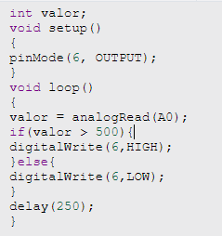

Source: Author's own (2024)

The Figure 4 below shows the result of the code, where the potentiometer is switched off, leaving the LED unlit:

Figur4 – LED Manipulation Programme Result

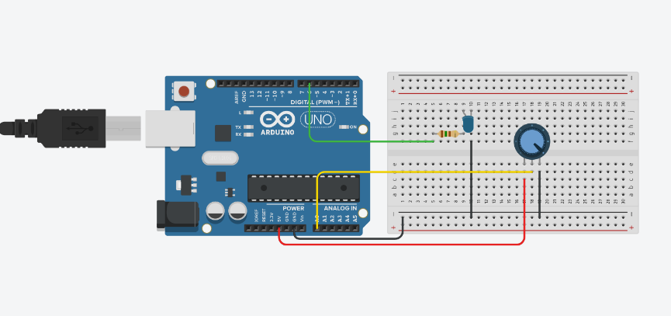

Source: Author's own (2024)

* 1. **React Native**

As explained by Escudelario and Pinho (2020), React Native is considered to be a React library that provides various tools to help create mobile applications for iOS and Android, using support languages such as HTML and CSS. It was introduced in 2015 by Facebook. It allows developers to reuse knowledge of web technologies to develop mobile applications, facilitating their creation, as mentioned by Bezerra and Viana (2021). It adopts a ReactJS syntax, using JSX. However, its approach differs from its roots. Because its elements are emulated natively, using JS Core as a bridge between the two as cited by Silva and Sousa (2019).

Figure 5 – Folder Structure And Basic Form in React Native

Source: Author's own (2024)

The Figure 5 above shows a simple form code as a sample application.

* 1. **Firebase**

As mentioned by Firebase (2024), the service is an application development platform provided by Google. It offers a variety of cloud and database services, covering systems for web and mobile devices. Firebase has several specific libraries for each tool, simplifying the process for developers, who only need to identify and install the necessary libraries as presented by Mezzari, Leal and Viegas (2019).

* 1. **Firestore**

Firestore is a highly versatile and scalable database solution, an integral part of Firebase. Using a non-relational approach ideal for mobile application development, as discussed by Araújo and Azevedo (2019). To paraphrase Martins (2023), it plays a vital role in the efficient management and storage of information. Thanks to its capabilities, it is possible to create apps with exceptional scalability and performance. As recalled by Firebase (2024), the tool offers support for regionalization of the database, providing a server in São Paulo, thus reducing latency and increasing availability for regional projects. Given this information, we opted for Firebase, as well as Cloud Firestore, due to a number of factors. The platform is suitable for meeting the diverse and ever-changing requirements of the project, as presented by Oliveira (2023).

1. **Methods**

Following Gil's (2017) explanation, the current project adopted qualitative and quantitative methods, an approach that combines numerical data with interpretative experience to arrive at broader understandings of canine cardiac health. The author classifies the quantitative method as a practice aimed at obtaining information with a numerical content, using statistics and data. The qualitative approach, on the other hand, takes an interpretative approach, considering conditions and occasions that are not quantified.

Applying it to the project presented, during the quantitative phase, some statistical analyses were conducted regarding the prevalence of heart disease among dogs, depending on their age group and activity profile. The basis would be the collection of information relating to risk factors, including age, sedentary lifestyle and obesity, cross-referencing this with the diagnosis of heart problems in search of patterns that could be used in the development of the app.

In this way, the qualitative phase involved integrated analysis of case studies and veterinary reports. These documents in fact provided substantial detail on the effects of heart disease among dogs in relation to their general well-being and how these conditions manifest themselves in different contexts. Collecting reports between owners and veterinary health professionals provided greater understanding of the early signs of heart complications.

A mixed methods approach was used to identify and develop a cardiac monitoring device. It crossed quantitative data, providing a broad statistical view of heart disease, with qualitative information showing the pragmatic implications of these conditions, thus enabling the development of a product focused on heart problems and risk mitigation.

1. **Results and discussion**

Despite all development steps and grounds found in the project, the hypothesis that a technological system could be useful for the purpose of monitoring dogs' cardiac health with the intention of preventing such complications as arrhythmias and serious heart disease cannot yet be fully confirmed or refuted.

Besides this, its outcome depends on external factors: cooperation by the owners themselves in following up on the recommendations given through the system, a task that also involves veterinary follow-up in those cases where warnings are raised. In the longitudinal analysis of the repercussions, the continuous use of the application will show effects on the cardiovascular health of dogs, as well as on the reception and adaptation of the target audience to this new technology.

Thus, while the first results seem to be encouraging, no proof or disproof of this hypothesis has come so far; it therefore opens up confirmations and refutations that could be made in the near future with more tests and assessments. While the potentiality of the project is bright, to emerge as a definite solution on a wide scale for cardiac monitoring, it needs much more robust validation.

Figure 6 – Home page and track beats from the mobile aplication

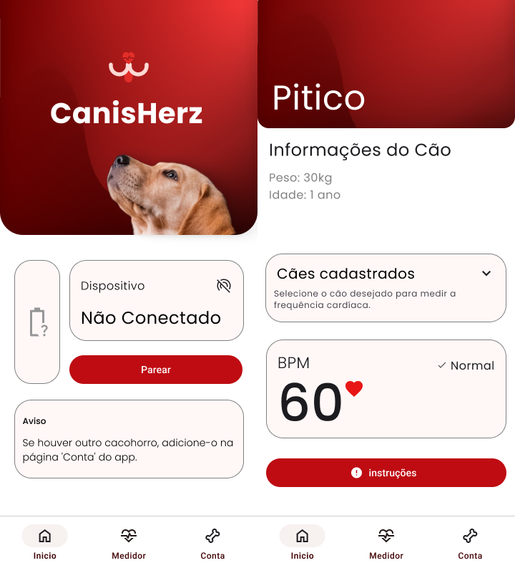

Source: Author's own (2024)

1. **Conclusion**

As it was discussed above, one could confirm in relation to the above-described reasons that yes, technology really can bring closer health monitoring to pets, and generally to the heart health of a dog. It has been an exciting project, showing how veterinary care can be complemented with real-time monitoring in an easy and approachable manner. These integrated quantitative data on the prevalence of diseases, coupled with qualitative opinions from veterinary professionals using case studies, will lead to the development of an innovative tool that can be used to mitigate risks related to heart conditions in dogs, increasing your daily health.

Moving forward, we want to retain this application as it continuously evolves, embedding advanced features in the future, including machine learning algorithms that can predict possible health risks and thus send out even more personalized alerts. We further find ways to develop such a device that it can be used easily in most different environments and situations, not restricted by area or situation, without always having to go to a vet or specialized equipment.

Although it is still a prototype and limited in many ways, the results have been encouraging. It is surely a promising step ahead into the technology-based monitoring of dogs. We are hopeful that it can trigger further research and development helpful in the continuous shaping of technology-driven solutions.

**References**

AGUILAR, Luis Joyanes**. Programação em C ++:** Algoritmos, estruturas de dados e objetos. 2. ed. Porto Alegre: AMGH, 2011.

ESCUDELARIO, Bruna de Freitas; PINHO, Diego Martins. **React Native:** Desenvolvimento de Aplicativos mobile com React. 2020. E-book.

FILHO, Antonio Mendes da Silva. **Introdução à programação orientada a objetos com C++.** Rio de Janeiro: Elsevier, 2010.

GIL, Antônio Carlos. **Como elaborar projetos de pesquisa**. 6. ed. São Paulo: Atlas, 2017.

JERICÓ, Márcia Marques; NETO, João Pedro de Andrade; KOGIKA, Márcia Mery. **Tratamento de Medicina Interna de Cães e Gatos**. Rio de Janeiro: Roca, 2015.

MAGRANI, Eduardo. **A Internet das Coisas.** Niterói: Cândido, 2021.

MEZZARI, Lucas Torres; LEAL, Eduardo Henrique Viva; VIEGAS, Silvio.Internet das Coisas: Arduino, Firebase e Android. **Gestão e Tecnologia**. Gravataí, v. 5, n. 1, set. 2019.

MORAIS, José V. M. **ESP32 com IDF**: O Guia Profissional. São Paulo: Instituto Newton C Braga, 2023.

SILVA, Denys Alves; SOUSA, Caio Frias. Construção de App com React Native. **Tecnologias em Projeção**. Brasília, [v. 10, n. 1, ago.](https://revista.projecao.br/index.php/Projecao4/issue/view/106) 2019.

SANTOS, Sandro. **Introdução à Iot:** Desvendando a Internet das Coisas. Joinville: Clube dos Editores, 2019.

SINCLAIR, Bruce. **IoT:** Como Usar a "Internet Das Coisas" Para Alavancar Seus Negócios. São Paulo: Autêntica Business, 2018.

ZELENOVSKY, Ricardo; MENDONÇA, Alexandre. **Microcontroladores:** Programação e Projeto com a família 8051. Rio de Janeiro: MZ Editora Ltda, 2017.

ARAÚJO, Guilherme Ianhes; AZEVEDO, Rodolfo Jardim. **Implementação de um Sistema de Quiz no Aplicativo WebLectures.** 2019. Relatório Técnico (Graduação em Computação) – Universidade Estadual de Campinas, Campinas, 2019.

BEZERRA, Franklyn Seabra Rogério; VIANA, Wilson. **Desenvolvimento Nativo vs Ionic vs React Native:** uma análise comparativa do suporte à acessibilidade em Android**.** 2021. TCC (Graduação em Computação) - Universidade Federal do Ceará, Fortaleza, 2021.

FRANCO, Matheus Felipe Souza. **Percepção de tutores sobre a saúde e qualidade de vida de cães cardiopatas.** 2022. TCC (Bacharelado em Medicina Veterinária) - Universidade Federal da Fronteira Sul, Realeza, 2022.

MARTINS, João Antônio Bandeira De Oliveira. **Uma ferramenta para otimizar a relação instrutor-aluno em academias.** 2023. TCC (Bacharelado em Ciência da Computação) – Universidade Federal de Campina Grande, Campina Grande, 2023.

OLIVEIRA, João Olívio Scaramussa Fávero. **Desenvolvimento de uma solução com gamificação para estudos de engenharia de requisitos.** 2023. TCC (Bacharelado em Sistemas da Informação) – Instituto Federal do Espírito Santo, Cachoeiro de Itapemirim, 2023.

PASCOAL, Pedro Gelati. **Desenvolvimento de um sistema para monitoramento da frequência cardíaca em atividades físicas.** 2020. TCC (Graduação em Engenharia Elétrica) – Universidade Regional do Noroeste do Estado do Rio Grande do Sul, Ijuí, 2020.

SANTOS, Wallef Ferreira. E**quipamento de baixo custo para monitorar temperatura e umidade de forma contínua e remota:** aplicação na compostagem. 2023. 53 f. Trabalho de Conclusão de Curso (Bacharelado em Engenharia Ambiental e Sanitária) - Centro de Tecnologia, Universidade Federal de Alagoas, Maceió, 2021.

AGÊNCIA DE NOTÍCIAS DE DIREITOS ANIMAIS. **Um em cada 10 animais morrem no Brasil por problemas cardíaco**s**.** 2013.Disponível em: <https://anda.jor.br/um-em-cada-10-animais-morrem-no-brasil-por-problemas-cardiacos>. Acesso em: 11 de set. 2024.

CONSELHO REGIONAL DE MEDICINA VETERINÁRIA DO ESTADO DE SÃO PAULO. **Pets também podem ter problemas cardíacos.** CRMV-SP, 26 set. 2019. Disponível em: https://crmvsp.gov.br/pets-tambem-podem-ter-problemas-cardiacos/. Acesso em: 2 jun. 2024.

FELDMAN, Andre. **Cardiopatia**: o que é, sintomas, causas, tipos e tratamento. 2024. Disponível em: https://www.tuasaude.com/cardiopatia. Acesso em: 10 de abr. 2024.

FIREBASE. **Armazene e sincronize dados em tempo real.** Disponível em: https://firebase.google.com/products/realtime-database?utm_source=bing&utm_medium=cpc&utm_campaign=latam-BR-all-pt-dr-SKWS-all-all-trial-e-dr-1707800-LUAC0016441&utm_content=text-ad-none-any-DEV_c-CRE_-ADGP_Hybrid%20%7C%20SKWS%20-%20MIX%20%7C%20Txt_%20Compute-Firebase-KWID_43700067403163247-kwd-78684157082834%3Aloc-20&utm_term=KW_Firebase-ST_Firebase&hl=pt-br. Acesso em: 27 de abr. 2024.

FRAGATA, Fernanda. **10 sintomas para detectar doenças cardíacas em cães,** 2014 Disponível em: https://epoca.globo.com/colunas-e-blogs/fernanda-fragata/noticia/2014/04/10-sinais-para-detectar-bdoencas-cardiacas-em-caesb.html. Acesso em: 28 de ago. 2024.

MARTINS, João Antônio Bandeira De Oliveira. **Uma ferramenta para otimizar a relação instrutor-aluno em academias.** 2023. TCC (Bacharelado em Ciência da Computação) – Universidade Federal de Campina Grande, Campina Grande, 2023.